EXPERIMENT:6: Create a simple cloud software application for Payroll Processing System using any Cloud Service Provider to demonstrate SaaS include the necessary fields such as Name of the employee, experience in present org , over all experience, basic pay, HRA, DA, TA, net pay, gross pay etc

STEP:1 : CREATE A APPLICATION FORM FOR THE EMPLOYEE DETAILS.

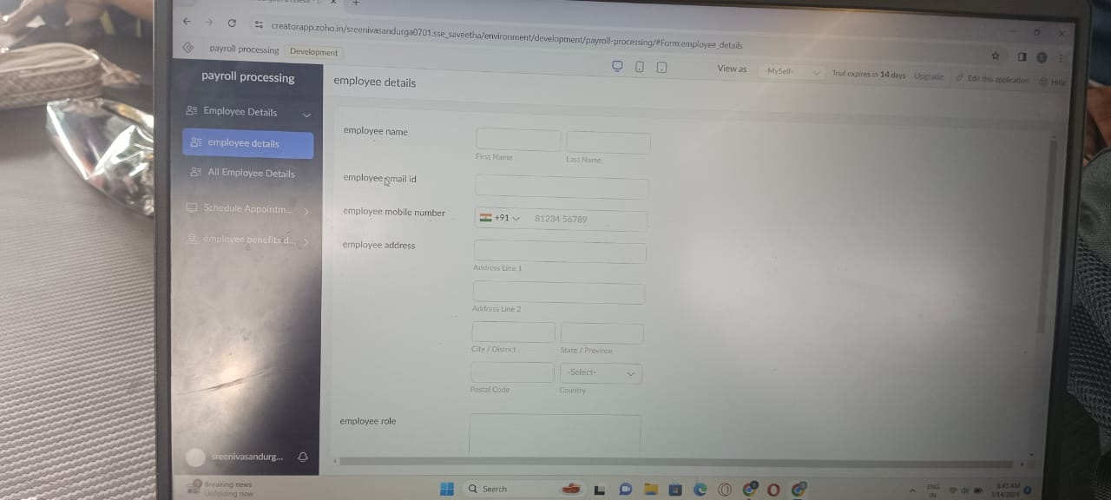

STEP:2 : CREATE A APPLICATION FORM FOR NEW APPOINTMENTS.

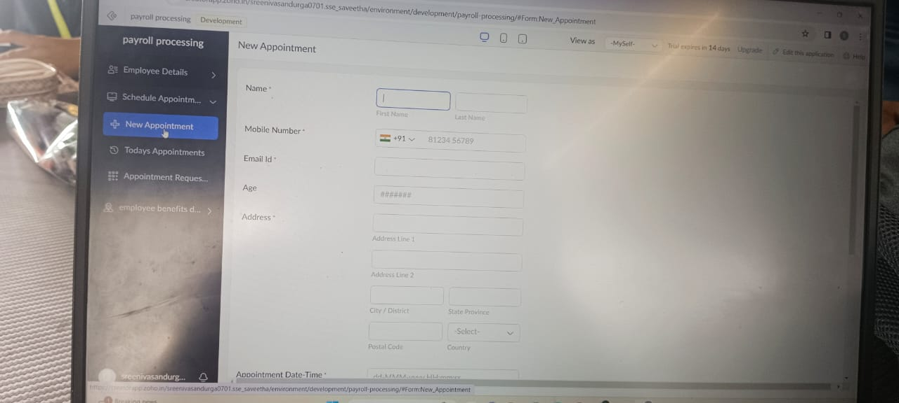

STEP:3 CREATE A APPLICATION FORM FOR EMPLOYEE BENEFITS.

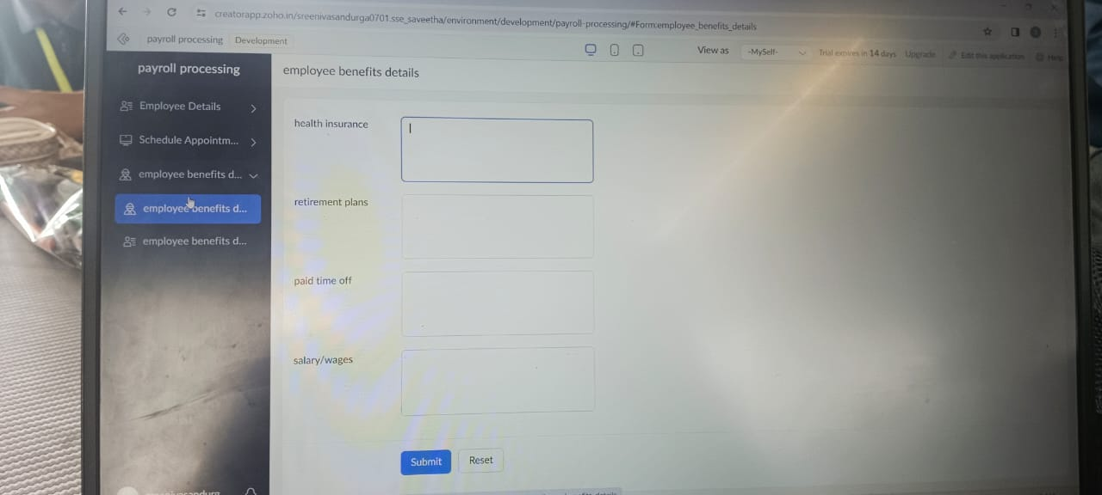

STEP:4: CREATE A PAYROLL RESULT AT LAST.

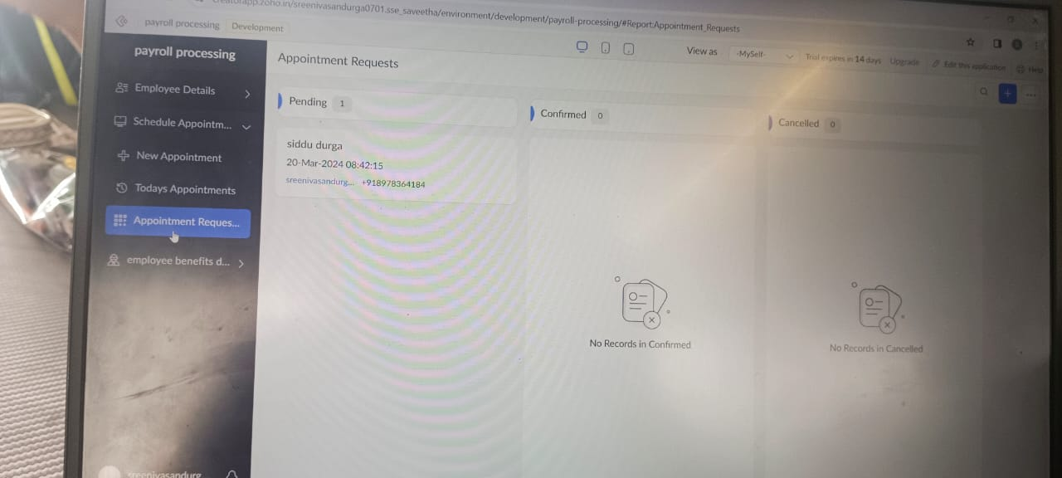

RESULT: THUS,THE PROGRAM FOR THE PAYROLL PROCESSING SYSTEM HAS BEEN EXCEUTED SUCCESFFULLY.